The spelling bee will begin with a preliminary judging on Oct. 26, and passers can take part in the secondary test on Nov. 9.
Contestants will be given an opportunity one at a time to spell a word picked randomly by a judge. If the spelling is wrong, he/she will be eliminated from the competition; if correct, he/she will be asked to wait on another turn to spell a word. Students are allowed to ask the meaning and part of speech of the word before attempting to spell it. This process will continue until ten students remain in the secondary test.
2017 The Eighth Alemayehu Paul Annual Spelling Bee Competition

PRIZES
1st place 1000 RMB and a trophy
2nd place 800 RMB and a trophy
3rd place 600 RMB and a trophy
4th & 5th places 300 RMB each
6th -10th places 200 RMB each

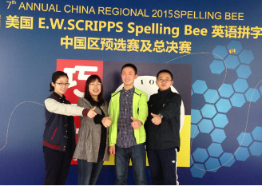
The top-10 students will meet in the final competition on Nov. 23 (Thanksgiving Day). The same process will continue until one student is left on stage, and he/she will be considered the winner.
Students preparing for the preliminary judging, secondary test and the final will get three different lists of words respectively chosen from TEM4 & 8 vocabularies.

